**Linux Hands-on Session Day-4**

**1) Copy one file from one linux machine to another linux machine using scp command.**

scp filename username@ip:/destinationpath

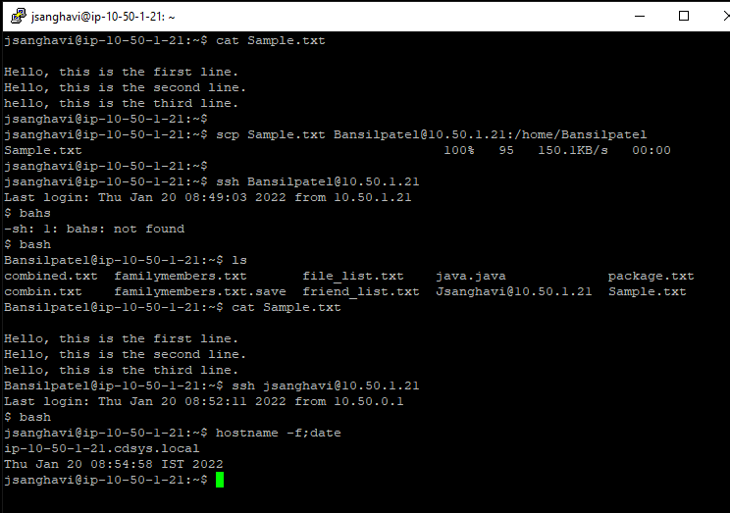

**2) Find the location of files that have the specific word.**

-R for recursive search and -w for finding exact words and -e for pattern.

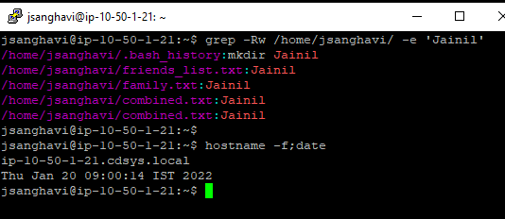

**3) How to find the process id which is running on a specific port?**

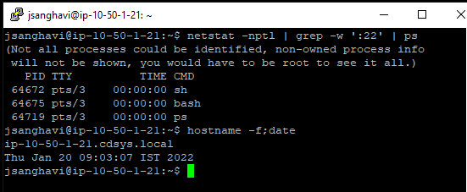

**4) Find the lines which have specific words from the log files using grep command.**

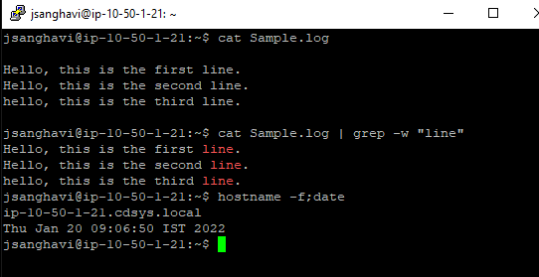

**5) How to provide file permissions to file, user and directory?**

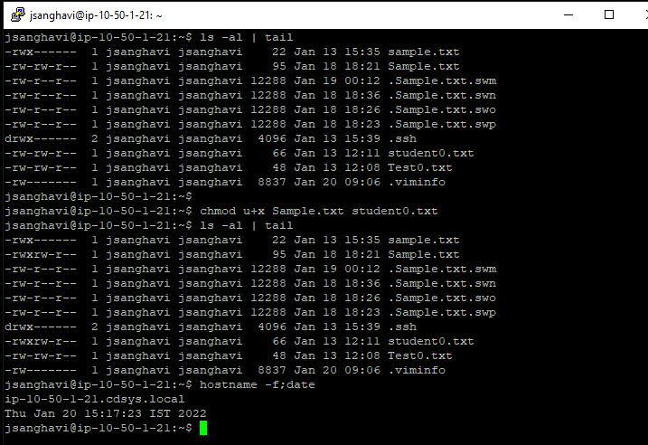

**6) How to do Archiving and Compression of any folder?**

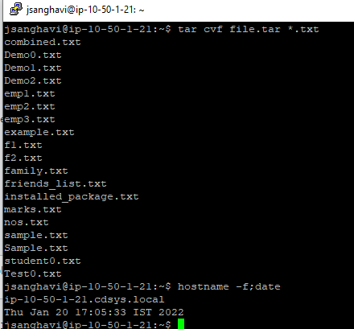

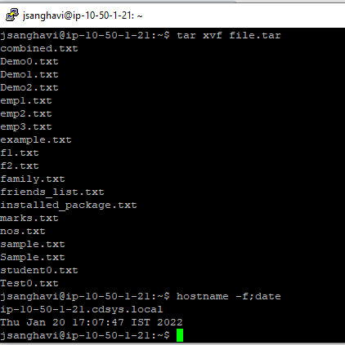

**7) Any other 10 commands not discussed in the session.**

**tac:** Displays file content in a reverse order.

**sleep:** Used to hold the terminal for a specified amount of time.

**sed:** Used to edit streams using regular expressions.

**awk:** Used for text processing in Linux.

**fdisk:** To display partition information on a Linux system.

**whereis:** Looks through a list of standard directories and works independently of your search path.

**type:** Displays information about the command.

**locate:** Locates the files and directories in the local file system.

**exec:** Executes a shell script or the program in place of current process.

**unset:** Removes a variable or the function.

**cmp:** Compare two files.

**comm:** Compare two sorted files.

**yes:** Output a string repeatedly until killed.

**nl:** number the lines in the file.

**8) How to find hidden files in a directory?**

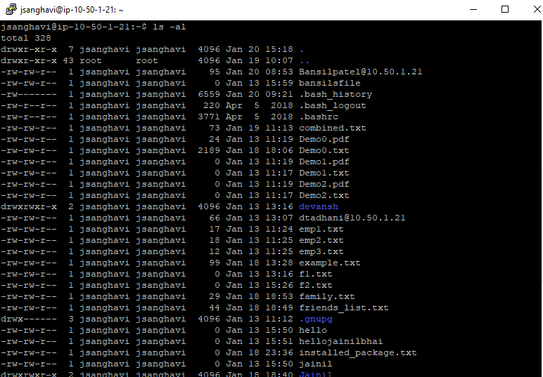

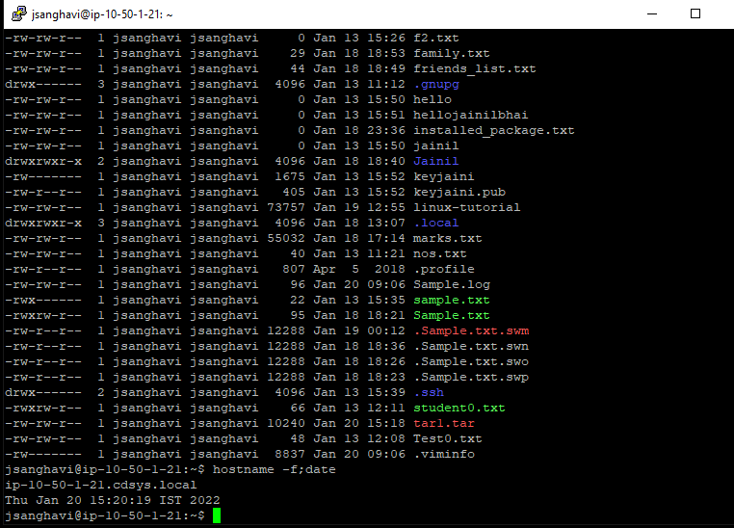

**9) How can you find out how much memory Linux is using?**

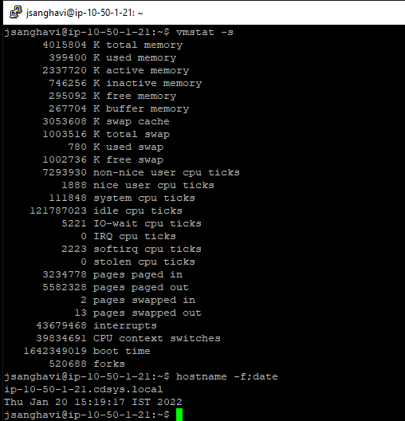

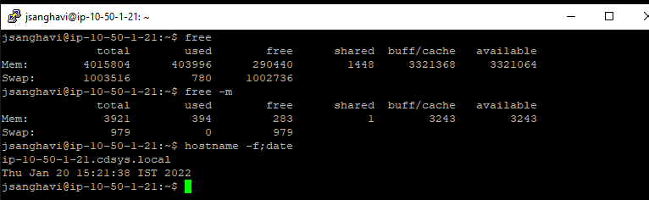

**10) Write a command that will display all .txt files, including its original permissions.**

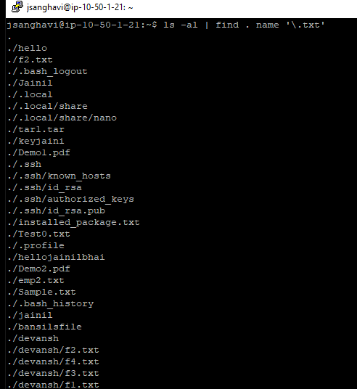

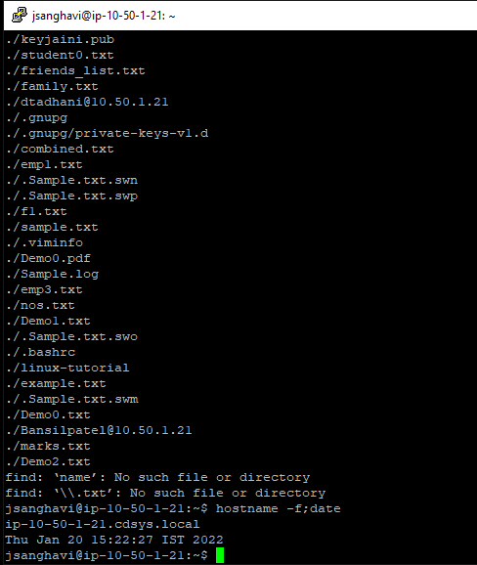

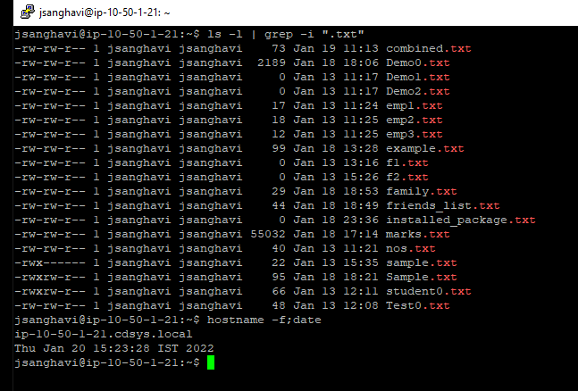

**11) How can you find out the status of a process?**

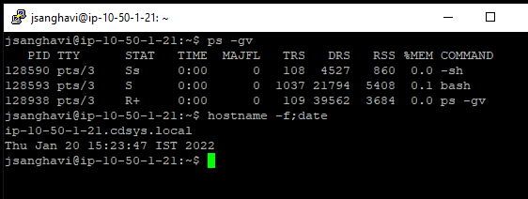

**12) How can you check the memory status?**

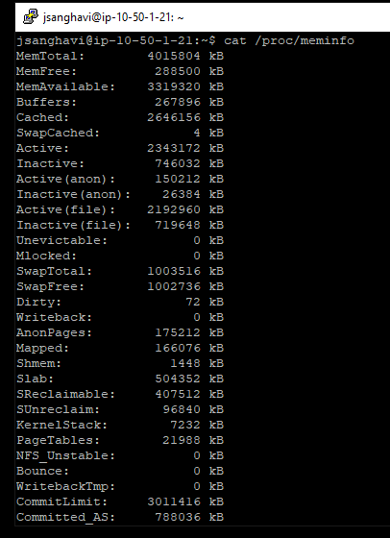

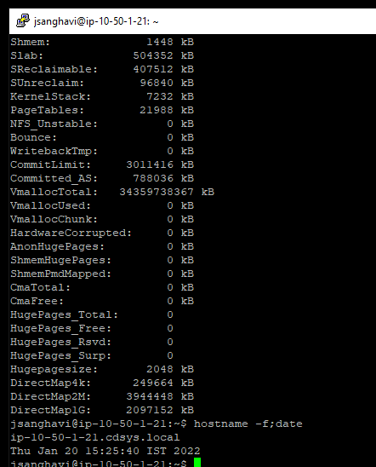

**13) Write commands used to set a processor-intensive job to use less CPU time.**

We can renice the value for a process.

Command: renice +10PID

cpulimit -l value -p PID

**14) Explain how you can find a file using Terminal.**

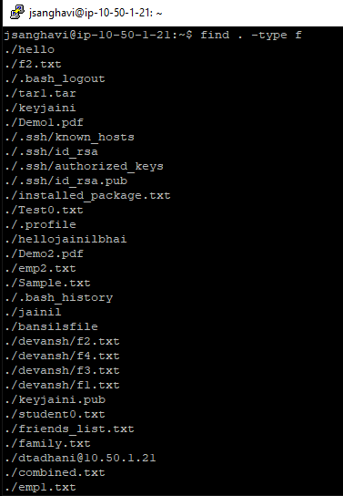

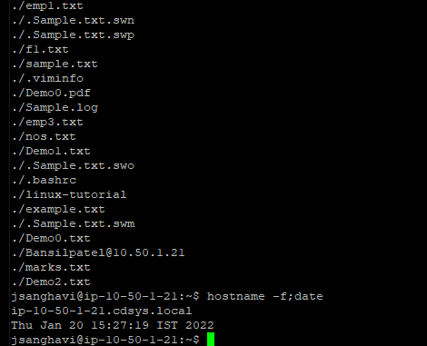

**15) Create an ssh key and add it’s identity.**

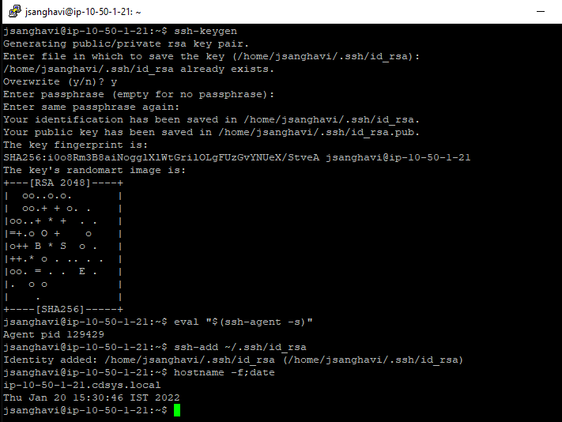

**16) Create a bash script to find if a number is perfect or not.**

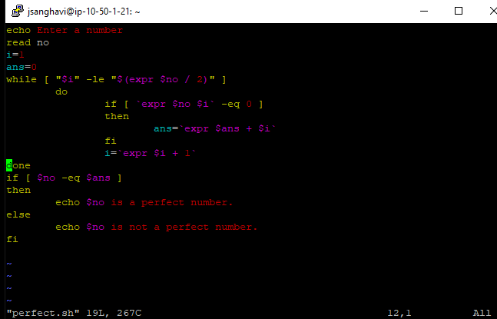

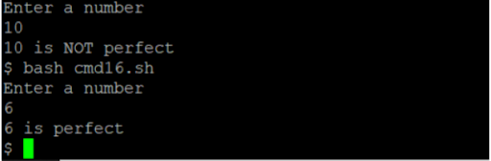

**17) Write a shell script to print a number in reverse order. It should support the following requirements:**

1. **The script should accept the input from the command line.**
2. **If you don’t input any data, then display an error message to execute the script correctly.**

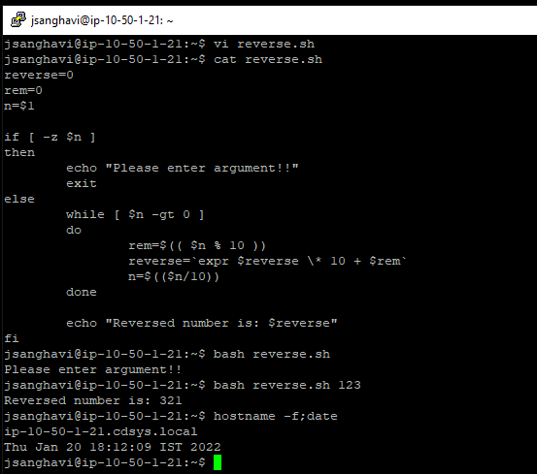

**18) Write a shell script to validate password strength. Here are a few assumptions for the password string.**

**Length - minimum of 8 characters.**

**Contain both the alphabet and number.**

**Include both the small and capital letters.**

**If the password does not comply with any of the above conditions, then the script should report it as a <Weak Password>.**

